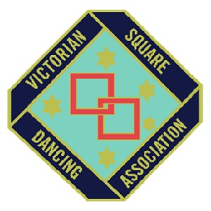
AG2022
Victorian Square Dancing Association Inc.
Reg: A0005828F, ABN: 83 174 149 517
A.G.M. Meeting Agenda.
To be held on the 13th of March 2022 at 10am
Arthur Wren Hall 16-20 Stuart Avenue Hampton Park

- Chairperson: - Andrew Verhoef
- Returning Officer: -
- Scrutineers (2)

- Do we have more than 10% of voting members present to form a quorum?
a) Members = Min of ____ voting members in attendance -
- Meeting opened:
- Election of a Minute Secretary
Moved:-
Seconded:-
Carried:-
- Apologies:
- Recognition of Delegates:-
VCA
RDAV
- Confirmation of the minutes of the 2021 A.G.M.
Moved:-
Seconded:-
Carried:-
- Correspondence:

- V.S.D.A. Presidents Report: -
Moved:-
Seconded:-
Carried:-
- Treasurer’s Report: -

Payables as of 31st December 2020:
Moved:-
Seconded:-
Carried:-
- S.A.V. Editor’s Report: -
- Membership’s Officers Report:-
- Friendship Officers Report:-
Moved:-
Seconded:-
Carried:-
- 2021 State Convention Report:-
Moved:-
Seconded:-
Carried:-
- Promotion Report: Unfortunately due to Covid 19 we have been unable to do much in relation to promotions this year. Things that we have done is collaborate with NSW and SA societies to run a national radio advertisement please see below:
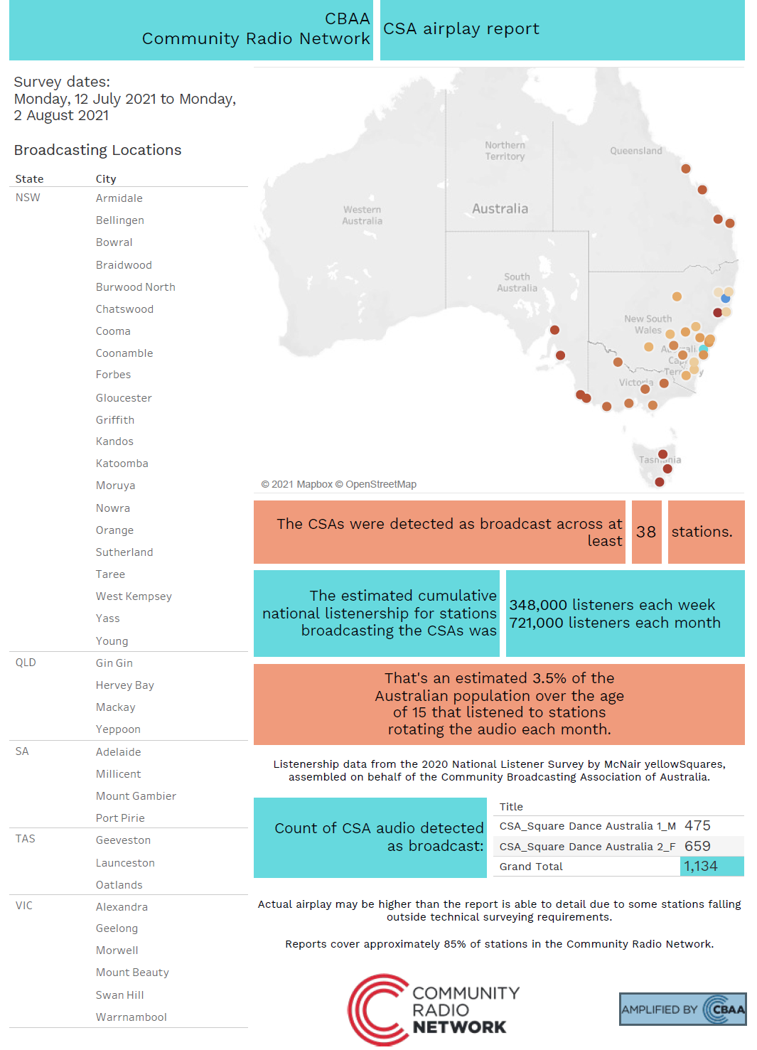
Promotional hopes and plans for 2022:
Radio Advertising

Moved:-
Seconded:-
Carried:-
- V.C.A. Presidents Report: -
Moved:-
Seconded:-
Carried:-
- R.D.A.V. Presidents Report: -
Moved:-
Seconded:-
Carried:-
- Ratification of Fees: -
- General Business:
Moved:-
Seconded:-
Carried:-

- Special Business:
- Election of Officers.
Scrutineers:
As per the model rules the members must decide on how many general committee members will be elected for the following year and therefore the current committee put forward the following motion.
Motion: That there be only 8 General committee members positions for the year 2021-22
Moved:-
Seconded:-
Carried:-

Election of Officers POSITION | MOVED | SECONDED | RESULT
PRESIDENT

VICE PRESIDENT

SECRETARY

TREASURER

GENERAL COMMITTEE

- Introduction of the New Committee.
Executive Committee for 2022-2023
President
Vice President
Treasurer
Secretary
General Committee for 2022-23
- Meeting closed at:

